Infosys Springboard Virtual Internship 6.0 Completion Report
Batch Number - 13
Start date- Feb - 14
Names:
Team A
Abhishek Shah

Internship Duration: 8 weeks

1.Project Title
FitPulse Health Anomaly Detection from Fitness Devices

2. Project Objective
The primary objective of this project is to address critical data quality deficiencies in raw fitness and health datasets—sourced from wearables and HR systems—that arrive with significant gaps and inconsistencies. FitPulse aims to dissolve these barriers through intelligent, fully automated data remediation, allowing analysts to proceed immediately to insight generation.

3. Project description in detail
FitPulse Analytics is an automated technical platform that enhances health data intelligence by analysing style, performance, and trends. It features a robust five-stage pipeline architecture to handle datasets from hundreds to tens of thousands of rows:
1. CSV Ingestion: Utilises robust encoding detection and file-state guards to transform raw data into in-memory DataFrames.
2. Null Inspection: Provides multi-dimensional audits, including heatmaps and KPI cards (Total Nulls, Null Rate), to isolate missing fitness metrics.
3. Preprocessing Engine: A deterministic five-layer engine—covering datetime parsing, linear interpolation, forward/backward fills, and median/mode fallbacks—that guarantees 100% null elimination.
4. EDA Generation: Instantly produces 8 interactive charts, including Pearson correlation matrices and distributions, to map physiological relationships.
5. Pattern Extraction: Advanced analytics for weekly/monthly average trends and outlier detection.
This system reduces pre-analysis preparation time by an estimated 70–85%.

4. Timeline Overview
Week | Activities Planned | Activities Completed
Week 1 | Setup environment and implement Stage 1 (CSV Ingestion). | Established Streamlit environment and native file_uploader logic.
Week 2 | Develop Stage 2 (Null Value Inspector). | Implemented multi-dimensional audits and initial coverage reporting.
Week 3 | Implement Layers A & B of the Preprocessing Engine. | Completed datetime parsing and linear interpolation for time-ordered metrics.
Week 4 | Complete Layers C, D, & E of the Preprocessing Engine. | Finalized ffill/bfill and median/mode fallbacks for continuity.
Week 5 | Integration of Stage 5 (EDA Generation). | Developed histograms, weekly-average line charts, and Pearson heatmaps.
Week 6 | Advanced Trend Analysis and Pattern Extraction. | Implemented time-series trends using pandas resampling protocols.
Week 7 | Anomaly Detection and Dashboard View. | Built dashboard implementing Isolation Forest-based anomaly flagging.
Week 8 | Containerization and Deployment. | Containerised and deployed the project using Docker.

5a. Key Milestones
Milestone | Description | Date Achieved
Project Kickoff | Initial planning and architectural brief. | December 1
Prototype Draft | Initial Streamlit UI and Stage 1/2 Ingestion logic. | December 15
Mid-Term Review | Integrated 5-layer preprocessing and PEP-standard validation. | December 27
Final Submission | Completed dashboard view and full pipeline deployment. | January 9
Presentation | Final demo to mentors and peer group. | January 23

5b. Project execution details
The project was implemented in a modular and milestone-based manner, focusing on static data analysis and automated remediation. Python served as the primary language, with Pandas vectorized operations ensuring high-performance scalability for large datasets. The system supports interaction through a Streamlit-based UI and is designed for seamless integration.

6. Snapshots / Screenshots
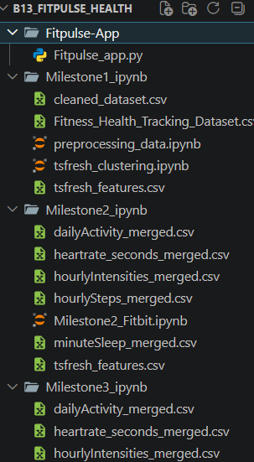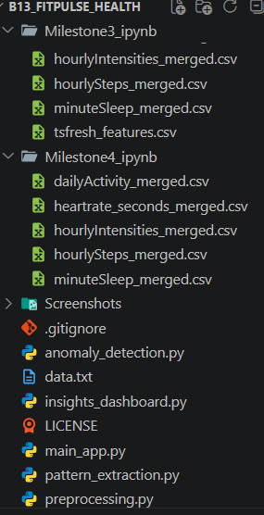
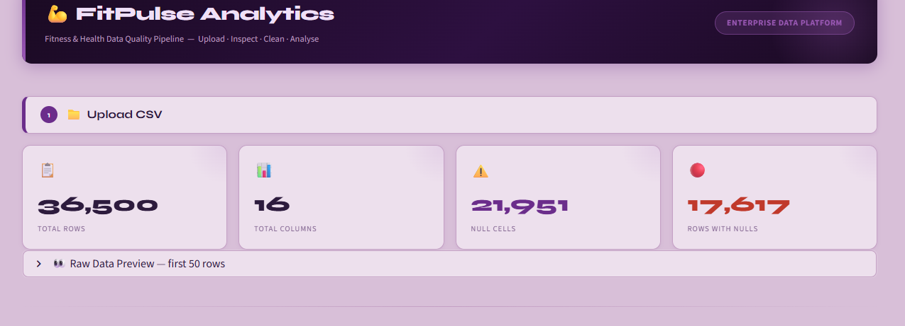
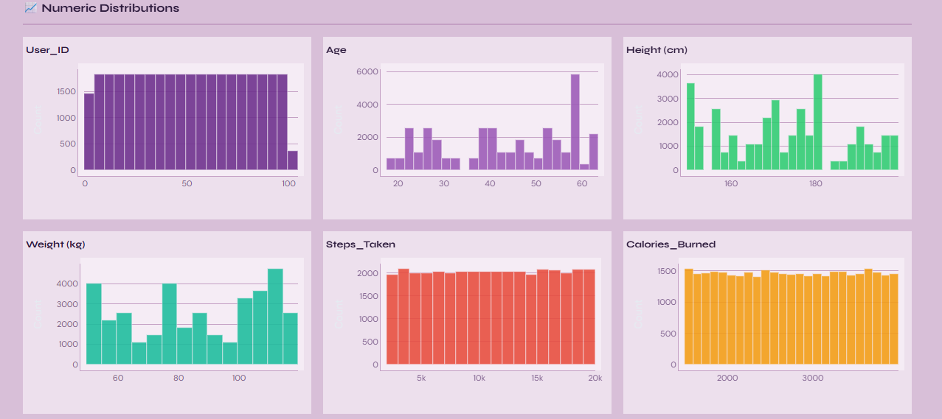
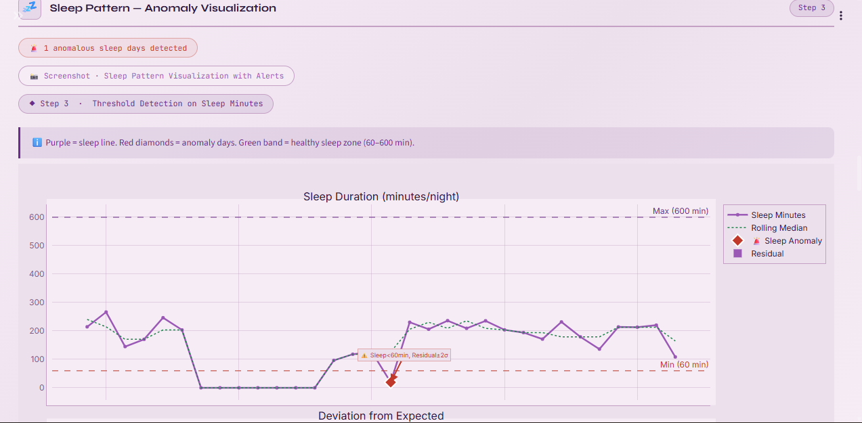
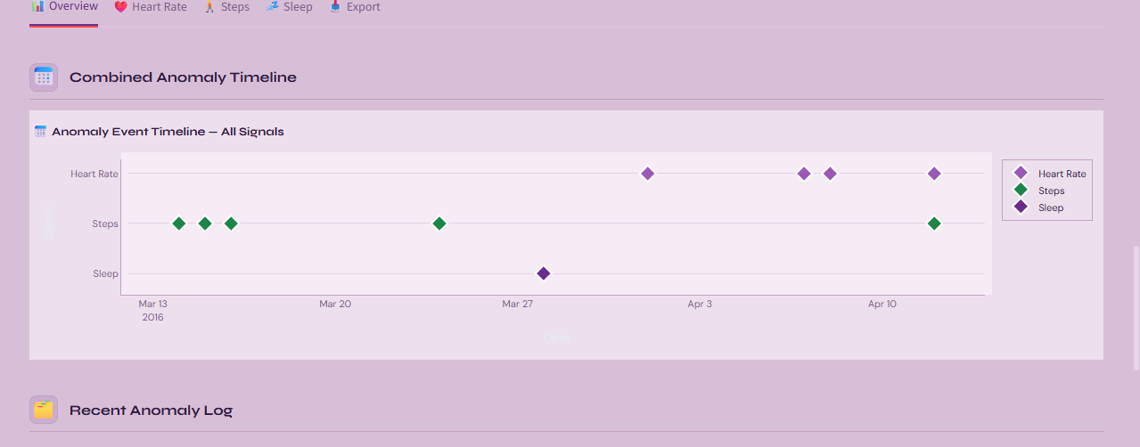

7. Future Development Roadmap
Version | Feature | Business Value
v1.2 | Multi-file Upload | Merge up to 5 CSV files via configurable join keys.
v2.0 | ML Anomaly Detection | Isolation Forest-based flags for unusual patterns.
v3.0 | Intelligent Anomaly Forecasting | Proactive Prediction using LSTM neural networks to predict anomalies before they occur, alongside Automated Root Cause analysis to explain cross-metric dependencies.
v4.0 | Beyond Visualization | GenAI Insights for human-readable strategic reports, Peer Benchmarking against anonymized norms, and ROI Scorecards to correlate health improvements with cost savings.

8. Challenges Faced
- Integration Complexity: Combining multivariate correlation analysis with AI-generated insights without producing redundant or misleading suggestions.
- Data Quality Barriers: Effectively managing pervasive null values and structural irregularities in raw wearable datasets.
- Accuracy: Ensuring generated feedback and anomaly flags remained accurate and actionable without AI hallucinations.

9. Learnings & Skills Acquired
- Technical Proficiency: Gained hands-on experience with Streamlit, Pandas, and LLMs for real-time data processing.
- Architecture Design: Developed modular, scalable software architecture with a clear separation of concerns between ingestion and analysis.
- Data Science: Improved proficiency in Python environment management, static analysis, and ML anomaly detection.
- Containerization: Exposure to Docker for standardized project deployment.

10. Conclusion
This internship provided valuable experience in designing and deploying a high-fidelity AI application for health data. It significantly enhanced both my technical and soft skills, aligning perfectly with academic goals in AI and Data Science.

11. Acknowledgements
I sincerely thank Infosys Springboard, my mentors, and academic coordinators for their continuous guidance and support throughout this development journey

